Project Part 1 Deliverable #1 - VPC

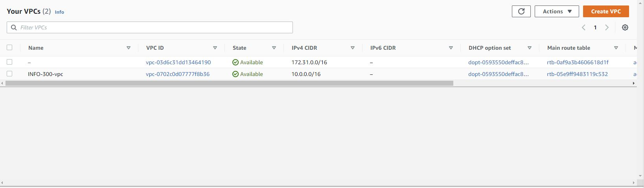

Project Part 1 Deliverable #2 - Subnets

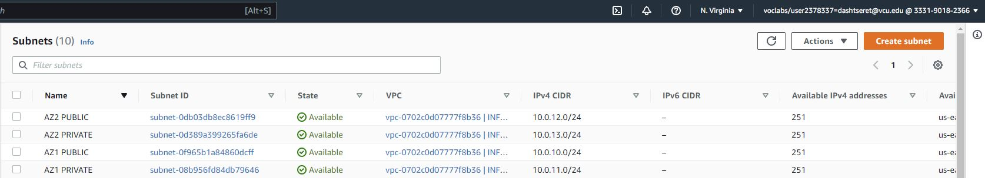

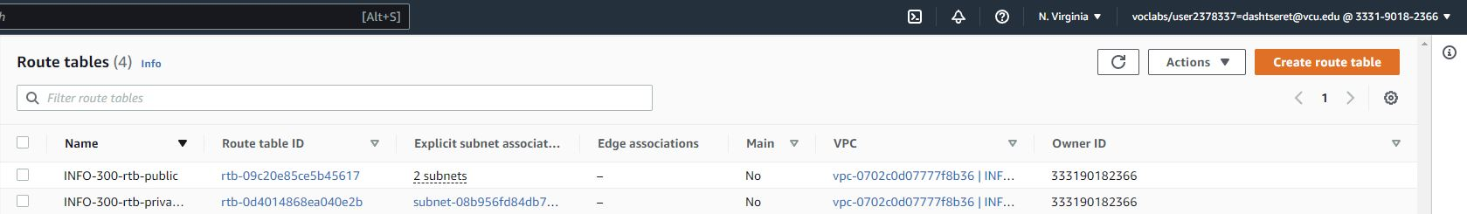

Deliverable #3 – Security groups

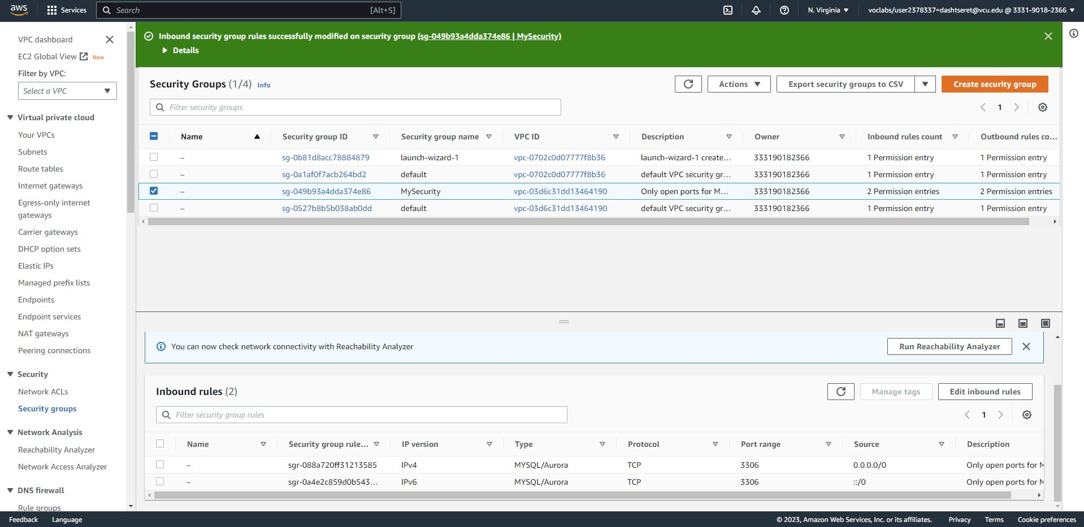

Deliverable #4 – Testing through DNS address.